Phần 1: Quản lý tiến trình

1. Ps -e

1. Ps -eo uid,pid,pri,cmd | grep -i bash

-eo(hiện thông tin theo)

1. Ps -ef | grep -I init



1. Nice -n 2 man top | more &

-n 2: độ ưu tiên bằng 2

&: chạy trong nền



1. Nice -n -2 ps -el | grep man

1. ps -ef

1. renice -n -2 man top | more &

1. nice -n 2 man top | more &



1. Ctrl + Z để tạm dừng tiến trình

1. Pstree

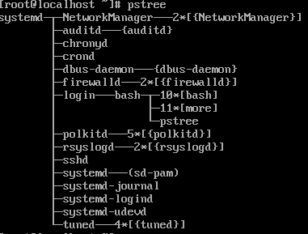

1. Ps -C more

1. Kill -9 53074

1. Pstree root

1. Top

Dòng 3 (%CPUs) 99.3 id là phần trăm máy rỗi

Phần 2: Quản lý người dùng

1. Useradd user1



1. Groupadd linux1

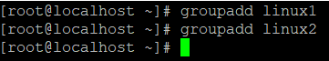

1. Usermod -a -G linux1 user1



1. Passwd user1

1. Useradd -m -d /home/user2_home -g linux2 user2 && echo “user2:1” | sudo chpasswd

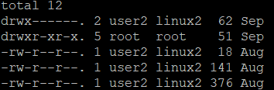

1. Usermod -l linux1 user1 | Usermod -l linux2 user2

Lưu ý: nếu hiện lỗi user is curently used by… thì nhập lệnh

Pkill -u user pid

Pkill -9 -u user

1. Sudo passwd -l linux2

Sudo vi /etc/passwd (thêm ! trước x)



1. Sudo passwd -u linux2

1. Sudo pkill -u linux1

Sudo mv /home/user1 /home/user1_home

Sudo usermod -d /home/user1_home -m linuxuser1



1. Chage -m (tối thiểu) -M (tối đa) <số ngày> <user>

1. Userdel -rf <user>



1. Groupdel <group>

